**Maharishi University of Management, CS472**

**Lab 2: CSS Design and Layout**

Except where otherwise noted, the contents of this document are Copyright 2012 Marty Stepp, Jessica Miller, and Victoria Kirst. All rights reserved. Any redistribution, reproduction, transmission, or storage of part or all of the contents in any form is prohibited without the author's expressed written permission.

*original lab idea and code by Victoria Kirst and Jeff Prouty; revised by Brian Le, Katlyn Edwards, Roy McElmurry IV, and Marty Stepp*

[Valid HTML5](http://validator.w3.org/check/referer) [Valid CSS](http://jigsaw.w3.org/css-validator/check/referer) [Valid JS](http://mumstudents.org/jshint/referer.php)

**Basic lab instructions**

* Read the instructions thoroughly from **start to end** before you begin with lab.
* Labs will be carried forward as assignments, if not finished in lab time.
* If you are done great! review slides, learn new stuffs on your own most important! **wait for meditation**.

**Today's lab exercises**

Today you'll style a "Victoria's Journal" page.

1. Arrange Your Page into Sections
2. Spacing With Padding and Margins, Backgrounds
3. Float, Alignment and Clear
4. Cosmetic Finishing Touches
5. Upload Your Page to the Web

* Resources: [Firebug](http://www.getfirebug.com/) (or Chrome console), lecture slides.

**Exercise : Arrange Page into Sections (~20-25 min)**

(The next 3 slides describe this exercise. Please read them all, then start.)

First download the following HTML file. Then open it in your text editor, and also open the HTML page on your hard drive in Firefox. Then move on to the next slide.

* [[html](http://mumstudents.org/cs472/2019-07-RS/Labs/2/journal.html) journal.html](http://mumstudents.org/cs472/2019-07-RS/Labs/2/journal.html)

**Exercise , details**

(See example screenshot on next slide.)

Organize journal.html by adding ids, classes, spans, divs and semantic tags. Then, add borders around these sections by editing your layout.css.

* The **borders** are all 5px thick and solid.
* The **colors** are the intuitive HTML color names, e.g. the red border is the HTML color red.
* *Hint:* To reduce the needed id and class attributes, consider using CSS **context selectors**.

The only major changes to make to the HTML are adding ids, classes, divs, and spans.

**Exercise , output**

Your page should look like this when you are done:

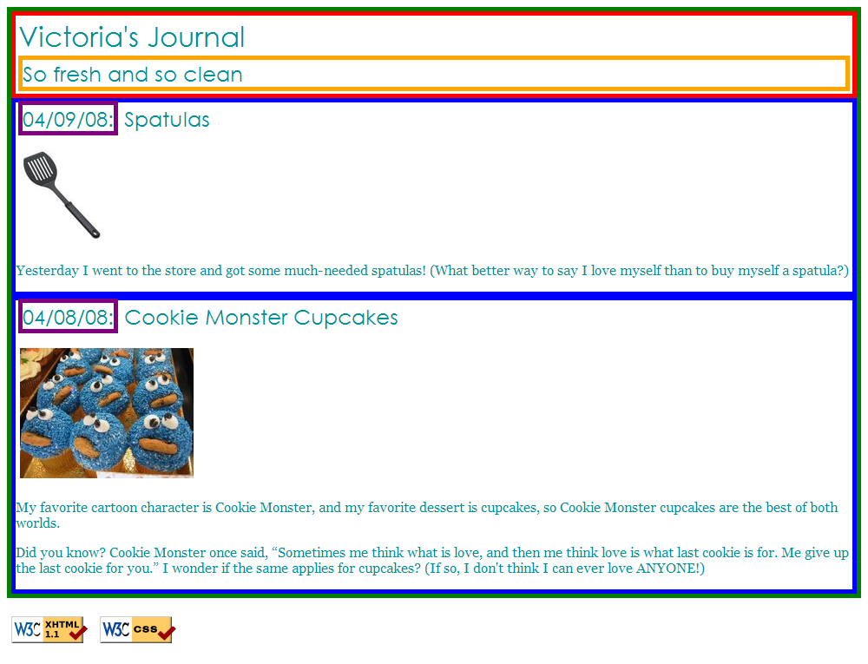

**Exercise : Padding, Margins, Backgrounds (~15 min)**

(See example screenshot on next slide.)

Add padding, margins, and backgrounds to the page. Change only your layout.css file.

* The box with the **green** border should have a background color of white.
* The boxes with the **blue** borders should have a background color of #E8FBFB.
  + It should have a padding of 5px (on all sides) and margin of 10px only on the *top* of the box.
* The **overall page content** area should become centered on the page, should have left and right margins of 10%, and the following background image:
  + spatula city background image (right-click and choose "Inspect Element" to find out its URL!)

**Exercise , example**

This example is Victoria's page with padding/margins and backgrounds:

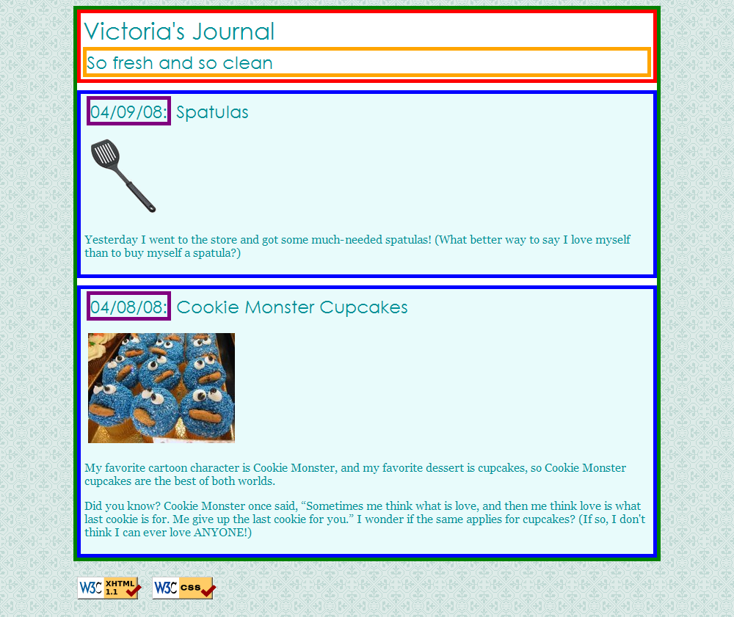

**Exercise : Float, Align, Clear (~15 min)**

(See example screenshot on next slide.)

Now we'll practice float, clear, and alignment. You may have to edit journal.html code as well as layout.css.

* The heading text in the **red** box should appear on the **right** side of that section of the page.
* The text of each journal entry should be widened so that each line fills the entire width of the section ("fully justified").
* The journal entry images should hover on the **right** side next to the surrounding text. The image should stay within the bounds of the blue box; that is, it should not bleed into the other content below it.
  + (*Hint:* If your boxes are not tall enough to fit the floating elements inside them, see the "Making Floating Elements Fit" in Chapter 4 of the textbook.)

**Exercise , example**

This example is Victoria's page with floating and alignment:

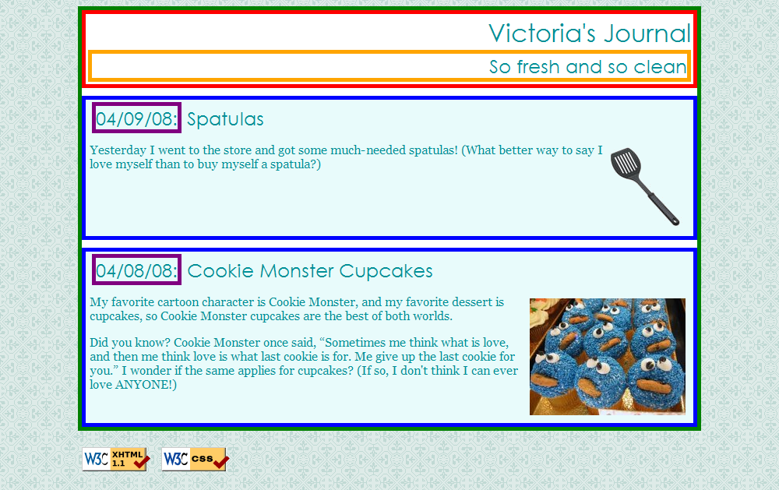

**Exercise : Finishing Touches (~10 min)**

(See example screenshot on next slide.)

* Change the box with the **green** border to have a solid, white, 10px-thick border.
* Change the boxes with the **blue** border to have a solid, 4px-thick border, in color #C2E9E9, with a 15px rounded **border radius**.
* Change the box with the **purple** border to have *only* a bottom border: blue, dashed, and 2px-thick.
* Change the box with the **red** border to have a background color of #A8F0F0, and get rid of its border.
* Change the font size of the So fresh and so clean area to 14pt, and get rid of its border.

**Exercise , example**

This example is Victoria's beautified page:

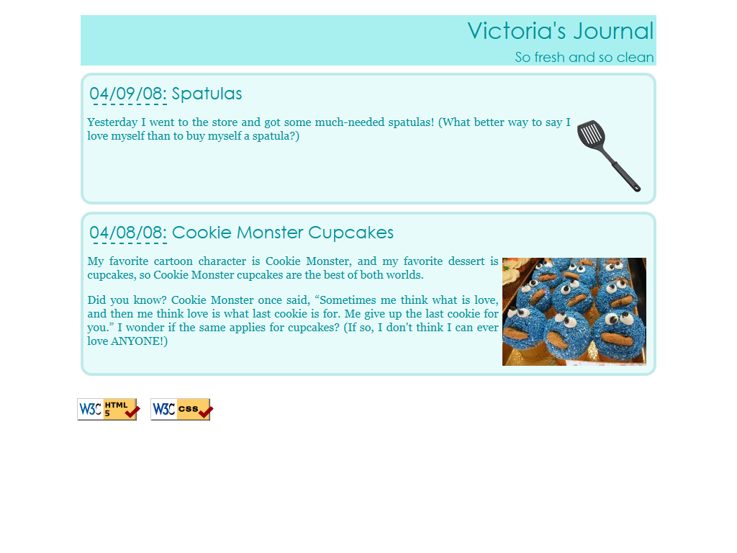

**Exercise : 2nd Column, Friends List**

(See example screenshot on next slide.)

Add a second column to the layout. Copy and paste the following code into journal.html:

<h1>Friends</h1>

<ul>

<li><a href="http://mumstudents.org/cs472/">cs472 Buddies</a></li>

<li><a href="http://www.willsmith.net/">Big Will</a></li>

<li><a href="http://youtube.com/watch?v=mZHoHaAYHq8" title="Conan the Librarian">Conan the Librarian</a></li>

</ul>

* Use the appropriate layout-related tags/attributes and CSS to make this list into a second, left-aligned column as shown below. The colors, borders, etc. of the list are not important; the focus is on the layout.
* **The layout with a second column must still be a liquid layout** -- that is, all parts of it should adjust in size accordingly when the browser size changes.
* *Hint:* When multiple elements float in the same direction, they arrange themselves into columns. Also see textbook Chapter 4's section on "The clear Property" for more information.

**Exercise , example**

This example is Victoria's page with the friends list:

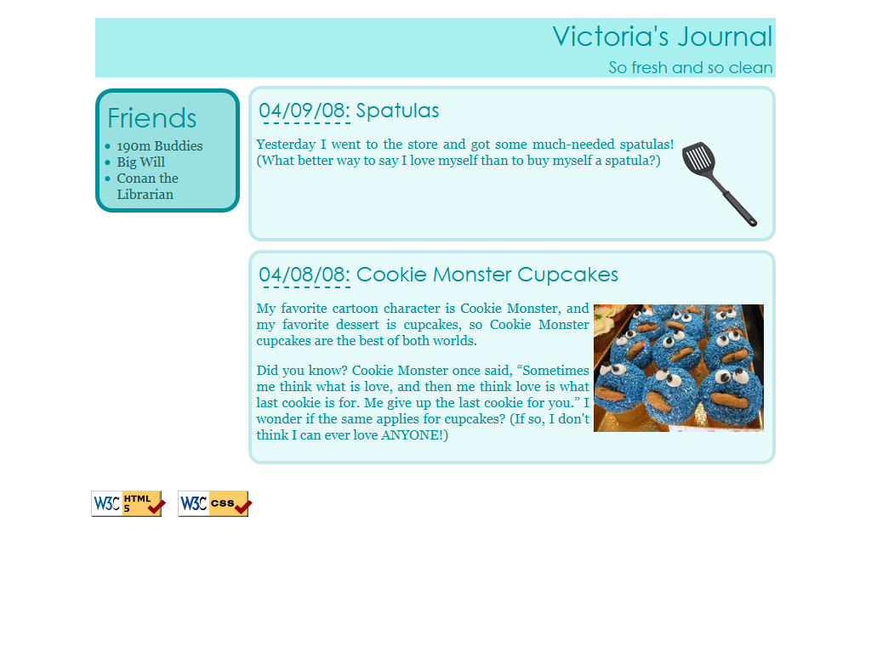

**Exercise : (h4x0rz only): Rounded borders**

The new CSS version 3 introduces borders with rounded corners.

* If they don't have them already, place rounded corners on your journal borders.
* Try making each of the four corners have a different amount of roundedness.
* Google to find out how to make the roundedness be elliptical, that is, have different horizontal vs vertical size.
* If you finish that, consider exploring some other properties from CSS 3, such as text shadows or multiple text columns.

**If you finish them all...**

If you finish all the exercises, you can add any other content or styles you like to your page.

If the lab is over or almost over, review lecture slides, learn new stuffs on your own and wait for Meditation.

**Great work!**